Q1. What is the major reason people being kidnapped in each and every state?

:

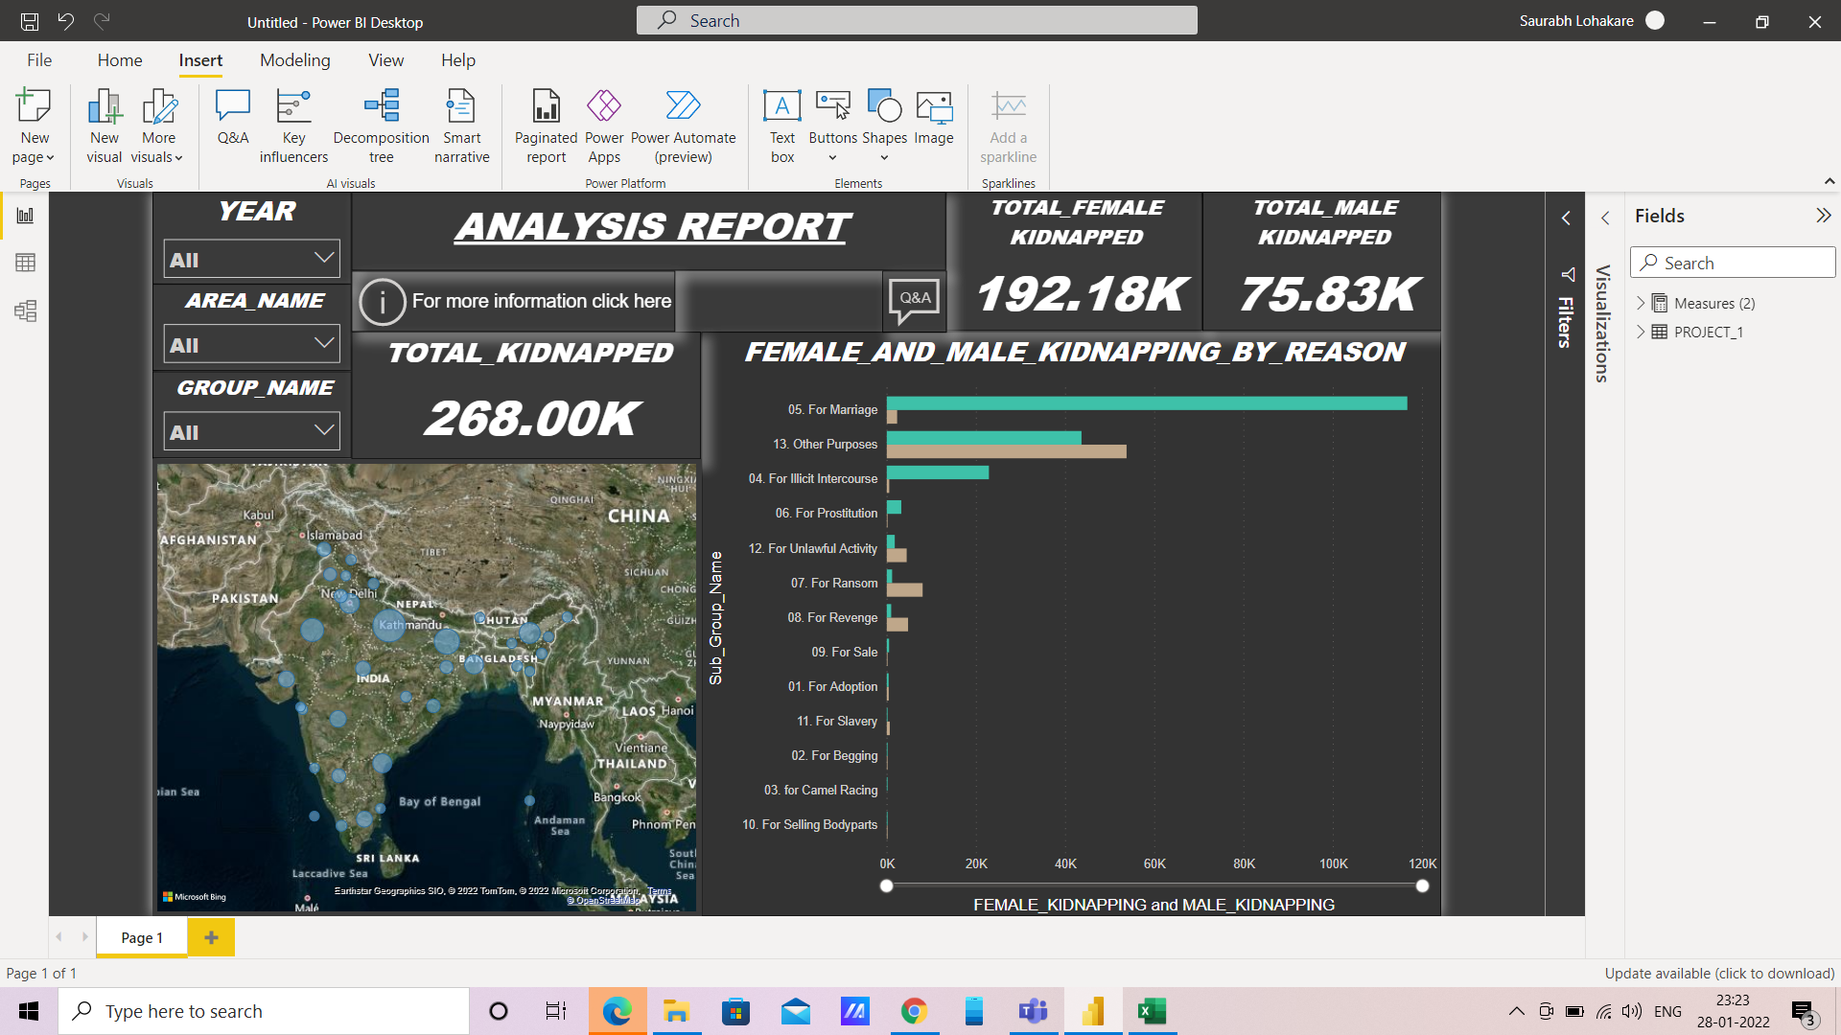

Q2. Offenders relation to the rape victim.

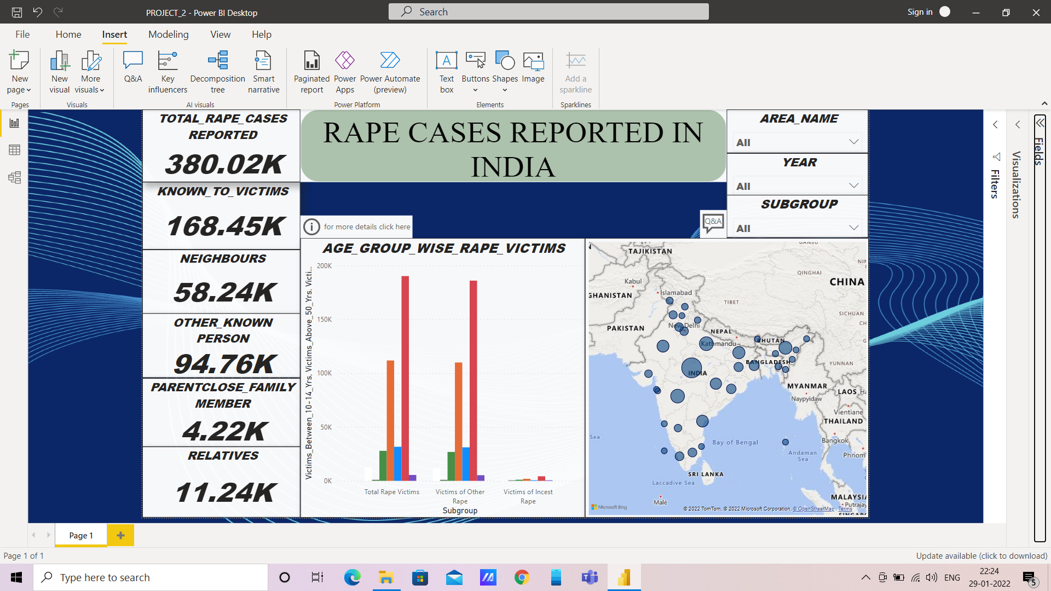

Q3. Juveniles family background, education and economic setup.

: 

Q4. Which state has more crime against children and women?

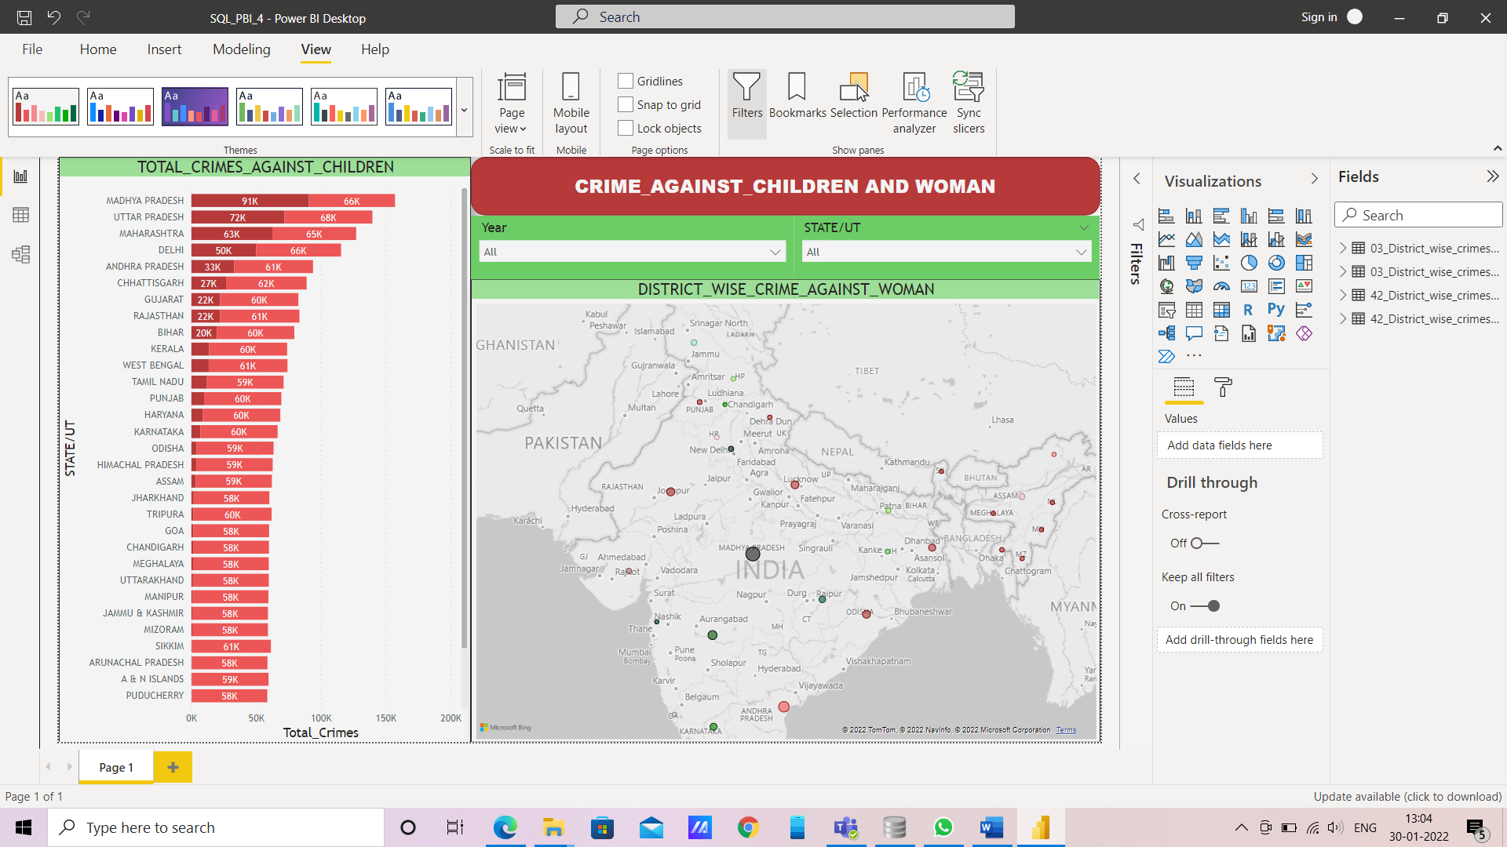

Q5. Age group wise murder victim.

: 

Q6. . Crime by place of occurrence.

: 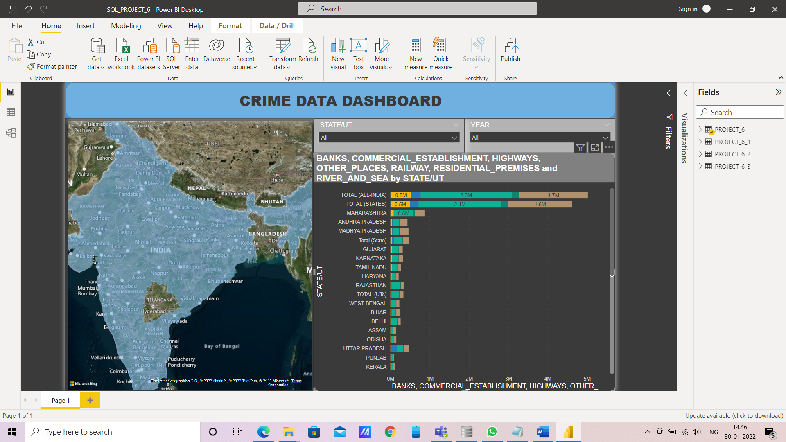

Q7. Anti corruption cases vs arrests.

: 

Q8. Which state has more number of complaints against police?

: 

Q9. Which state is the safest for foreigners?

:

